|  |  |
| --- | --- |
|  | dxFeed Market Data Services    Devexperts Inc.  2500 Plaza Five, Harborside Financial Center  Jersey City  NJ, 07311  USA  Tel/Fax: +1 201 633 4740    [www.dxfeed.com](http://www.dxfeed.com/)  [www.devexperts.com](http://www.devexperts.com/) |
| Dear Client,  We are delighted to welcome you as a new trial customer of dxFeed Data Services.  It is our pleasure to be of service to you today and always in the future.    Please find below the information pertinent to the activation of your dxFeed service.  DETAILS FOR CONNECTION:  •        **Feed address:**  rt1.ec2.dxfeed.com:7833  •        **Instrument profile service URL(list of all available instruments & their properties):**<https://tools.dxfeed.com/ipf>  •        **Instrument profile service login/pass:** michelle\_lin / ohmoyaab4Pae  CONTACTS  •        **Technical questions – dxFeed Service Desk 24/7:**  +1 855 565 55 36  [support@dxfeed.com](mailto:support@dxfeed.com)  **NB!** First time you send the email to [support@dxfeed.com](mailto:support@dxfeed.com) with short issue description in subject, the ticket will be created automatically. Then you’ll receive an invitation to dxFeed Jira Service, which allows to track progress on reported issues. **To report a new issue, please create a new thread.**  Please let me know if there are any other email addresses to be added for your access to Jira.  •        **Invoices and billing – our Finance department:**  [AR@dxfeed.com](mailto:AR@dxfeed.com)   DOCUMENTATION   For your reference, our documentation is available online:  •        [dxFeed API documentation minisite](http://docs.dxfeed.com/" \t "_blank)  •        [Other documentation](http://www.dxfeed.com/downloads/documentation/)   A few useful highlights:  •        [Symbology](http://www.dxfeed.com/downloads/documentation/dxFeed_Symbol_Guide.pdf" \t "_blank)  •        [Instrument profile data format](http://www.dxfeed.com/downloads/documentation/dxFeed_Instrument_Profile_Format.pdf)  •        [Chartserver data availability](http://www.dxfeed.com/downloads/documentation/dxFeed_Chartserver_Data_Availability.pdf" \t "_blank)  •        [Java API](http://docs.dxfeed.com/dxfeed/api/index.html)  WEB SERVICES  For your convenience, here are the addresses of some of our most used web services below:    1.     **Instrument profile and reference data web service**  <https://tools.dxfeed.com/ipf>  Your login and password will be provided to you by our Service Desk.  2.     **Demo of dxFeed web service**  Provides streaming and snapshot data via JavaScript and REST APIs.  <https://tools.dxfeed.com/hashtag> | |

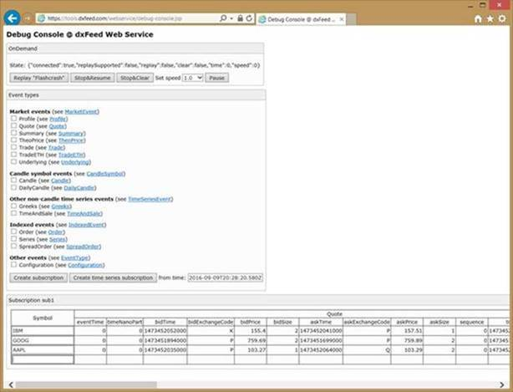

Some Information can be found on help page: <https://tools.dxfeed.com/hashtag/rest/help>

The description, request constructor, demo data feed <https://tools.dxfeed.com/hashtag/rest-demo.jsp>

Data can be requested in JSON or XML format. For example this is request for a snapshot of bid/ask price of EUR/USD and Bitcoin/USD pairs:  
<https://tools.dxfeed.com/hashtag/rest/events.json?events=Quote&symbols=EUR/USD:AFX,XBT/USD&indent>

You can use data event subscription via Server-Sent Events like:  
<https://tools.dxfeed.com/hashtag/rest/eventSource.json?events=Quote&symbols=EUR/USD:AFX,BCH/USD:CXBITS&indent>

Required JS libs and 3 samples how to get quotes, charts and other datatypes for download:

<https://seafile.in.devexperts.com/f/9baa931639ae4720a5de/?dl=1>

To configure server address you need to use *config.url* from *dxfeed.cometd.js* library

Main functions - *dx.feed.createSubscription* and *dx.feed.createTimeSeriesSubscription*, they are used to create connectivity and start receiving data from server.

Fields in server sent events are the same as class properties in our Java API. For example, for Quote events they corresponds to the Quote Class properties from API documentation available here:<http://docs.dxfeed.com/dxfeed/api/com/dxfeed/event/market/Quote.html>

The same approach shall be used for other events like Trade, Profile, Summary, Order, Candle and Underlying (for Futures/Options).

If you need more information on a specific subject, please ask [support@dxfeed.com](mailto:support@dxfeed.com), guys will help you.

DEMO VIEWER APPLICATION

**dxFeedViewer viewer application**is available for download in the [downloads section](http://www.dxfeed.com/downloads/demo/) of dxfeed.com.

Please use it at your convenience to quickly check our streaming data, troubleshoot your data feed, replay historical tick data or as a reference client application when developing your own solutions:

